HISTORY OF THE PUTTENHAM WAR MEMORIAL

In early November 2024 the Puttenham War Memorial was carefully repaired by Traditional Stone of Rudgwick in time for the Remembrance Day Service. This was also the year to commemorate the 80th anniversary of the D-Day Landings.
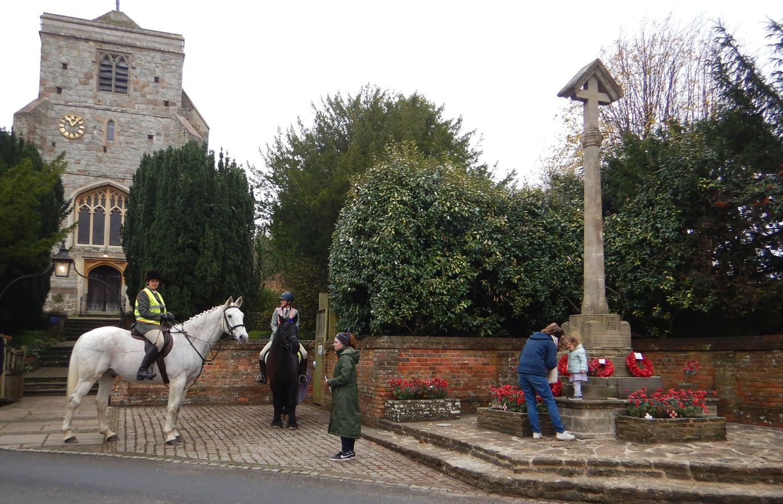
St John the Baptist Church (Grade II*) and the 1920 Puttenham War Memorial (Grade II)

The War Memorial stands outside St John the Baptist Church. It is a tall hooded cross on a traditional shaft with stepped plinth in Clipsham stone. The gabled cross-head has an octagonal shaft with carved cap and a base consisting of two octagonal steps on an 8’ square plinth. The paved area and steps around the memorial are in the local Bargate stone with a detail of iron stone paving at the junction of the tarmac road surface. Repointing and rebedding of the stone paving has been carried out in lime mortar and finished with a neat brushed joint.

The war memorial cross at the top of the village street was made possible by the donation of land by Ferdinand Smallpeice, the owner of Puttenham Priory and the consent of his tenant, C F Wood. The lowering of the surrounding walls and alterations provided a new entrance to the church. Previously the only entrance had been to the north side via an awkward path. Broad steps in three flights were constructed to the west side of the church along with a new gateway.

In October 1920, the Surrey Times described the memorial as ‘one of the most beautiful war memorials in Surrey,’ and describing ‘the Clipsham stone as having a beautiful texture and colour. The whole placed on a platform of Bargate stone with steps to suit the road levels.’

Clipsham is a limestone quarried for centuries in the Lincolnshire oolitic belt which is still quarried today near Peterborough. It has been used on restoration projects including Canterbury Cathedral, Windsor Castle and the Houses of Parliament. On the Puttenham War Memorial you can still see the skeletal fragments of a number of marine organisms such as molluscs, corals and forams which were formed in the seas millions of years ago. The Clipsham limestone is thought to have come from subtropical waters, a Jurassic formation of 168-174million years ago.
The cross was designed by William Douglas Caroe, FSA (1857-1938), an ecclesiastical architect whose firm continues to this day. There have been three generations of conservation architects, with Oliver Caroe making it four to the present day.

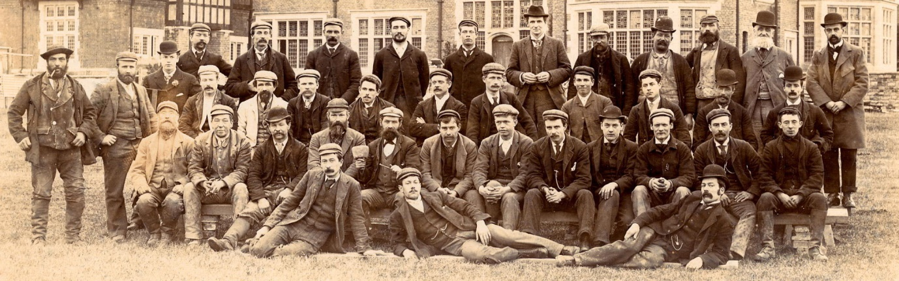
W T Jackson of Compton – the builders (courtesy of Aldro School archives)

The Clipsham stone memorial was made by Messrs Clary and Wright of Ipswich. The building works including alterations to the surrounding walls and Bargate stone platform was carried out by WT Jackson of Compton.

The war memorial was unveiled by Lord Midleton of Peper Harow on Sunday 3rd October 1920 after a special service in the church. It had been draped in a Union Jack, which covered the names of the fallen. He considered it a high privilege to be invited to do the unveiling describing: ‘six years ago, when the blow fell upon them from a cloudless sky, it caused upon them to undergo an ordeal such as the nation had never before had to face. Although that ordeal found the nation unprepared, it found them ready. One tenth of the 45 Million populations came forward voluntarily to save their country.’ Describing they had given their lives for the freedom of Great Britain. Previous battles such as Waterloo, the heroism of a single group or a single regiment might and did affect the outcome.

Midleton in his speech touched on the horrific reality that the bodies of those killed in conflict were not being repatriated stating: ‘It mattered little to those who have gone that their bodies were buried are away. What mattered was that those in that place should see that the names of those who had suffered for it should live or evermore.’ How could this have been a consolation to the loved ones or those returning with their lives.

As time was to show this was not the war to end all wars as Midleton expressed ‘Surely now that the chapter of war had closed, and the chapter of peace was opened, that very fact might be some inspiration to all of them.’ He felt ‘he had the pleasure in unveiling that memorial, to be preserved for all time by the people of Puttenham as their tribute to the saviours of their race.’

The memorial was then dedicated by the Rector, the Rev. Canon Cooke-Yarborough followed by the hymn: Now the Labourer’s Task is O’er. This was a popular hymn at the time and written by John Ellerton (1826-1893) and had been sung at the State Funeral of Edward II.

The hymn was followed by The Last Post and Reveille, sounded by buglers of the Queen’s Regiment. There was a guard of honour who marched past the cross, pausing a moment in remembrance of their comrades. The bells of the church were rung in a full peal after the service

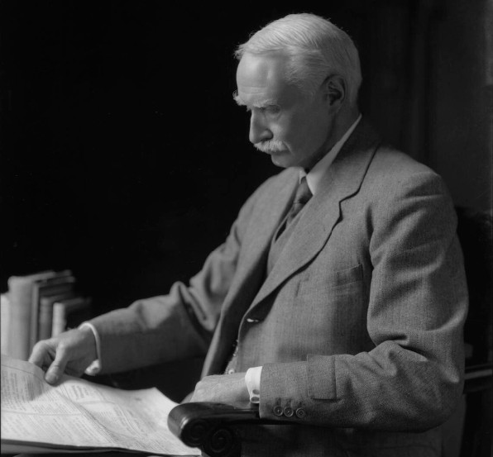
William Douglas Caroe – architect (courtesy of the National Portrait Gallery)

William Douglas Caroe (1857-1938) was born at Blundells near Liverpool, studied at Trinity College Cambridge and was articled to the church architect John Pearson 1881-1883. In 1883 he set up his own practice and in 1885 he was appointed architect to the Ecclesiastical Commissioners, subsequently working on numerous church projects throughout the UK. Caroe was commissioned to design an number of war memorials including St Peter and St Paul, Cromer(1919-1921), Stoke by Nayland, Suffolk (1920), Harrow on the Hill, Middlesex, (1921), Barrow upon Soar, Leicestershire (1921) to name a few.

The inscription on the socket and round the base is: In grateful remembrance of the men of this parish who laid down their lives in the Great War, 1914-1918
Sergeant Frederick George Burningham, Suffolk Regiment
Ernest Golding, Royal Engineers
John Golding,Norfolk Regiment
Cpl George Harmsworth, Royal Army Service Corps
Sergeant Charles A Jones, Royal Army Service Corps
Clement Madgwick, Royal Field Artillery
Harold W Serle, the Royal Fusiliers
Arthur Strudwick, the Queen’s Regiment
John Strudwick, the Queen’s Regiment
William F Taylor, Hampshire Regiment
Harry E Turrell, Leicestershire Regiment
Harry Wells, East Surrey Regiment

Commemorations First World War: 12 died
Second World War 12 died

Cross: 2311mm, height 5486mm, width 2311mm
Material: stone
Plaque: depth 57mm, height 280mm & width 736mm

Records and Sources:
Surrey History Centre: PUT/11/9/1-10 Papers relating to the War Memorial and churchyard alterations at Puttenham in 1920
Surrey Times and
County Express: Saturday 9th October 1920 pp6
Surrey Advertiser: Saturday 12 November 1921 Memorial Service pp14

2024 Repairs and Maintenance of the Puttenham War Memorial
Contractors: Traditional Stone, Pallinghurst Farm, Rudgwick, West Sussex RH12 3BQ
Works Contract Manager: Mike Baggaley 01403 824 000

Conservation Specialist: Sarah Sullivan BA (Hons), MCIAT, DipBldgCons(RICS)
The Forge, The Street, Hascombe, Surrey GU8 4JL

Structural Engineer: Clive Dawson
Hockley and Dawson, Birtley Courtyard, Bramley, Surrey GU5 0LA

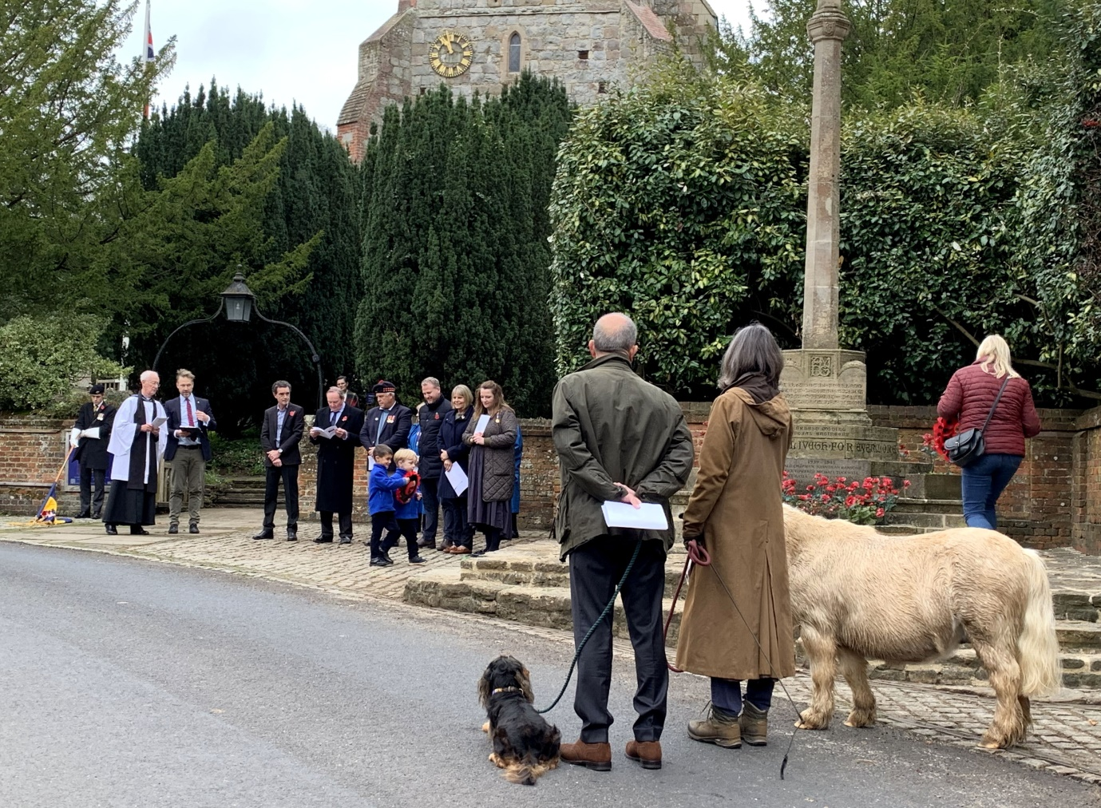
War Memorial Service – 10th November 2024

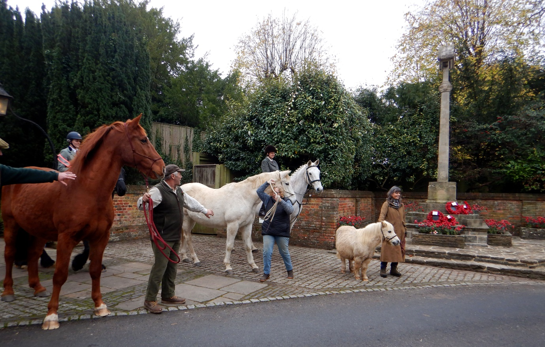
Horses on parade as part of the Remembrance Day

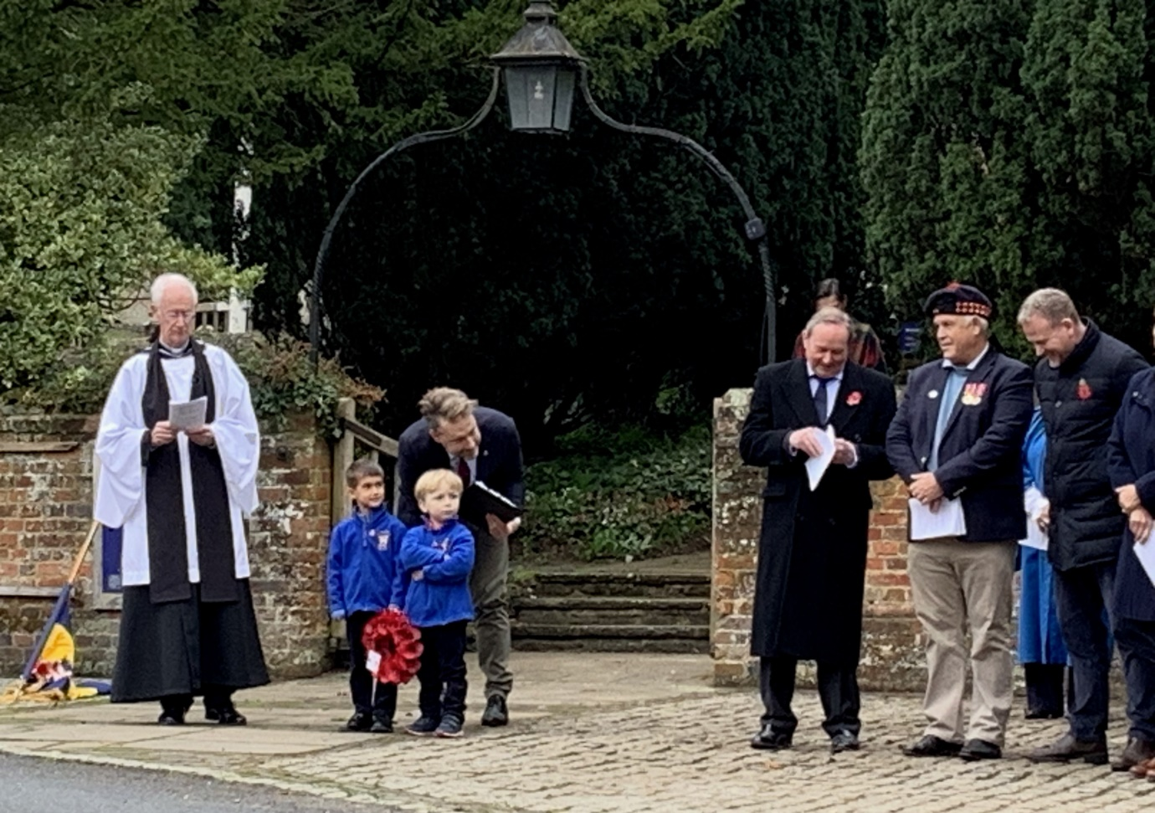
They shall not grow old as we that are left grow old:
Age shall not weary them, not the year’s condemn
At the going down of the sun and in the morning,
we will remember them.

