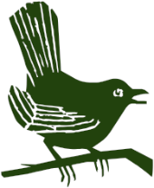
Puttenham Parish Council

Happy New Year to you all

Hedge Row and Tree Planting

Many thanks to the 20 volunteers who came and planted over 400 hedge whips and 12 trees, provided by the Surrey County Council Tree Department, who are aiming to plant 1.2 million trees in Surrey over the next year. With expert advice from the SCC tree team, the hedge and tree planting were placed along the fence line on the road to the car park and around the transport hub. In addition, a new memorial tree was planted next to the playground. These new hedgerow plants and trees are to improve the look around the transport hub and provide great habitat for wildlife and as a legacy for the future.

Munday’s Boro Bus Shelter

Rebuilt and completed ahead of schedule by local builders, JGT & Sons, the bus shelter now looks brand new.

Mike Blundell Jones
Chairman

