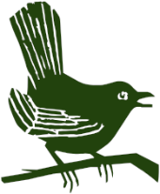
Puttenham Parish Council

HALOW Charity - Orchard Tree planting

At the end of January we once again welcomed back the children and youths from the HALOW charity, who always seem to experience and enjoy good weather when they come to Puttenham! This is the third year they have come and this time they planted another line of fruit trees on the west side of the Jubilee field, to complete our mini orchard, which is now triangular in shape.

ARCT
We would like to thank the volunteers from The Amphibian and Reptile Conservation Trust who came and completed the winter clear-up of Puttenham Downs. They also made safe a number of trees surrounding the dew pond and cleared the pond .which is located opposite the rear of the school and next to their forest school.
The Parish Council would like to thank both HALOW and ARCT for all their hard work.

Parish Precept

Unfortunately due to Guildford Borough Council’s financial situation, the annual Local Council Tax Support (LCTS) allowance that we have received for many years is not now being renewed. This means that once again we have no choice but to increase the precept to cover this lost allowance.

Mike Blundell Jones
Chairman

