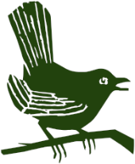
Puttenham Parish Council

Puttenham Downs

Over the last few years we have had an ongoing project to restore this strip of derelict land along the top of the Hogs Back into the original chalk downland flora, which was once so prevalent. Recently, for the third time, it has had its annual conservation cut, which is making a vast difference.

This project is managed in conjunction with the:-

Surrey Butterfly Conversation Trust – where we are trying to increase the Small Chalk Blue butterfly population with specialist seed planting and Bug Life B-Lines - where we have a 10 year agreement to produce a series of ‘insect pathways’ running through our countryside restoring and creating a series of wildflower-rich habitat stepping stones. This will provide large areas of brand new habitat benefiting bees and butterflies but also a host to other wildlife. The Amphibian Reptile Conservation Trust (ARCT) for the small pond we created, which is now a host to newts. Finally, The Community Orchard Team, who have planted a range of the original varieties of native Surrey apple trees.

Reminder - Electric Car Rechargers

These 2 rechargers are available for overnight or day time recharging and as a guide
1 hour charging will give you approximately 30 miles in battery range.

The “Emerald Village” Bonfire

Look forward to seeing you all at the magnificent Puttenham Bonfire on Saturday 8th November

Mike Blundell Jones
Chairman

